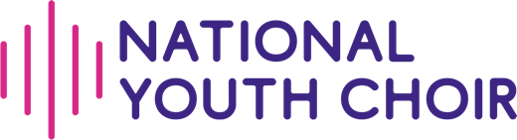

Members’ Handbook

National Youth Choir
(9-15 Years) and (15-18 Years)

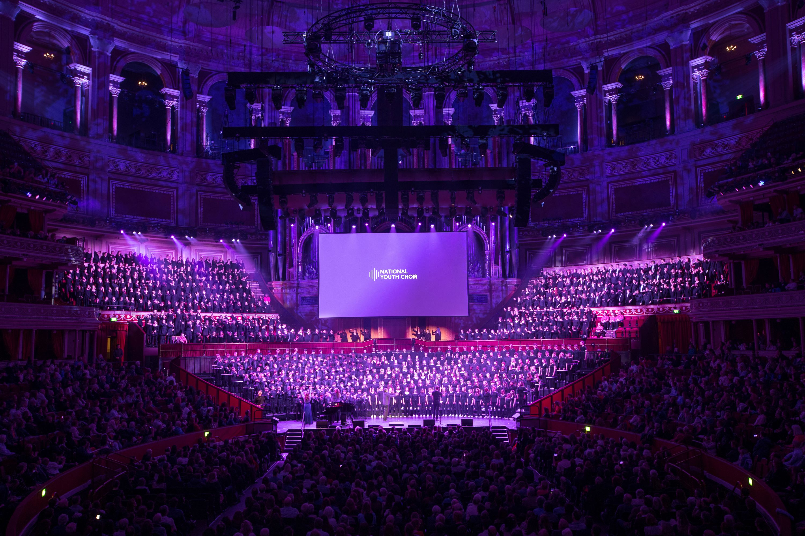

January 2026
Welcome to National Youth Choir!

Whether you’re a member, a potential audition candidate, or a parent or guardian of a young singer, we’re delighted to welcome you to the National Youth Choir community. This handbook has been developed to give you some more information about National Youth Choir (9-15 Years) and National Youth Choir (15-18 Years). If there’s anything you’d like to know that isn’t covered here, please feel free to get in touch with us anytime. You can also discover more about National Youth Choir (18-25 Years), National Youth Voices, our Emerging Professional Artist programmes, and our Learning & Engagement work on our website.

Introduction

National Youth Choir is a national champion for choral singing. We run choirs for more than 1000 enthusiastic young singers aged 9 to 25 from around the UK. Members of our choirs take part in inspirational residential courses (usually at spring and summer) and enjoy singing in concerts and high-profile performances. Our choirs also record music tracks and videos for release on streaming platforms and YouTube. In recent years, the National Youth Choir has been seen or heard on BBC1, ITV, BBC Radio 3, Classic FM and Scala Radio.

At National Youth Choir, we believe that all young people should have access to high-quality singing opportunities. We visit schools and other educational settings throughout the UK, all year round. We lead lively and engaging singing workshops for students from all backgrounds and with all levels of experience, encouraging them to find their voice and experience the joy of singing together. We work with teachers and other music leaders to help them develop their leadership skills and vocal confidence and support a wide range of music education networks through our partnership work.

We run training programmes for Emerging Professional Artists - our Fellowship, Young Conductor and Young Composer Programmes - which help to create the next generation of choral leaders, singers, conductors and composers. Emerging Professional Artists play an important role in supporting our younger choir members.

We are a registered charity. We run fundraising schemes and activities to ensure that no young person is prevented from taking part in the National Youth Choir because of financial challenges. We passionately believe that choral singing is for everybody.

Choirs

National Youth Choir comprises four main choirs:
- National Youth Choir (9-15 Years) is for young singers who are aged 9-15 by 31st August in the year before they attend a course. Candidates within school years 5 to 10 in England & Wales, Primary 5 to S3 in Scotland and P6 to Year 11 in Northern Ireland are invited to audition each autumn. The choir works primarily in two groups - female & non-binary singers and male & non-binary singers – but also has opportunities to work together as one group. We provide specialist support for young people with changing voices, and members can rest assured that whatever stage their voice is at when they attend a course, they’ll be well looked after and supported.
- National Youth Choir (15-18 Years) is for young singers aged 15-18 by 31st August in the year before they attend a course. Candidates in school years 11 to 13 in England & Wales, S4 to S6 in Scotland and Year 12 to 14 in Northern Ireland are invited to audition each autumn. This choir comprises female, male and non-binary singers for residential courses.
- National Youth Choir (18-25 Years) is for young singers aged 18-25. Candidates audition each spring and must be at least 18 by 31st August of that year. An annual programme of four projects then starts each September.
- National Youth Voices comprises members who are selected to join from NYC (18-25 Years) as well as NYC alumni and Emerging Professional Artists.

Auditions

Auditions to join NYC (9-15 Years) and NYC (15-18 Years) are held every autumn. We place successful applicants in a choir according to their school year – see ‘Choirs’ above. For full details of auditions, please visit: www.nationalyouthchoir.org.uk/national-youth-choir-9-18-years-auditions

Voice parts are allocated at the time of audition by our specialist music teams. Sometimes, this may be different from the voice part that the candidate is used to singing in another choir. Members may also be asked to sing a different voice part, in order to balance the choir, for a specific activity. Vocal health is a priority, and we revisit voice part allocation on a regular basis.

Membership

Members are invited to attend a spring course and/or a summer course each year and must attend at least one course each year to maintain their membership. Courses take place at venues around the UK and dates are set within the majority of state school holidays. Members who meet the minimum attendance requirement remain in their choir until they reach the upper age limit for that choir – see ‘Choirs’ above.

If a member is unable to attend either a spring or a summer course, we ask that they re-audition with a view to regaining their place in the choir in the autumn.

As we don't insist that all members attend both spring and summer courses, the number of members within a choir is greater than the number of places available on each course. We therefore ask our members to state their course preferences ahead of booking opening and assign courses to members based on a first-come, first-served basis. We also consider other factors such as the balance of voice parts and if a singer has siblings attending the same course. If you know that your young singer can only attend one course, we recommend that you state their course preference as soon as possible and don't wait for the deadline!

Under exceptional circumstances, if we have concerns about a member’s focus or abilities on a course, we will raise these with parents/guardians and may ask that the member re-auditions.

Financial Assistance

We believe that no young person should be prevented from taking part in NYC because of financial barriers. Financial assistance is available for ALL associated costs including travel to courses and concert tickets.

Through the kind support of our funders and donors we currently offer financial assistance to all applicants whose total household income is less than £70,000 per year. Assistance is offered on a sliding scale e.g. if your total household income is £45,000, we can offer you around 50% of the amount and if your total household income is less than £16,000 we can offer you around 100% of the amount you request. We also consider whether you have other dependents within National Youth Choir, whether your young singer participated in one of our SING! events, etc. as well as other exceptional circumstances that justify the need for some financial support so it is well worth applying!

Applications are usually submitted towards the end of November. Previous recipients of financial assistance also apply each year. However, if there have been no changes to their financial circumstances since the previous year’s application, they simply tick the relevant box when applying. If there is a change to their financial circumstances, they need to fill out the whole form with updated information.

Please visit our website to find out more: www.nationalyouthchoir.org.uk/financial-assistance

Costs

- One-off Membership fee for successful candidates which includes a black concert folder - £99
- Course fees – NYC (9-15 Years) / NYC (15-18 Years)
- NYC purple polo-shirt – up to £15 depending on size, plus postage
- Concert tickets for public performances

Residential Courses

NYC courses offer a trademark high-quality experience, to take young singers’ musicianship and singing skills to the next level. They are developed and run by our specialist team of world-class choral professionals who deliver rehearsals, sectionals, musicianship training and workshops.

Courses take place twice a year during the majority of state school’s Easter and summer holidays. This allows members to attend their regional and local choirs throughout the rest of the year. Courses take place at venues nationwide to reflect the geographical range of our members and to enable audiences around the UK hear our great young singers. NYC (9-15 Years) courses take place over five days and NYC (15-18 Years) courses over eight days. Where possible, we offer members a choice of two summer courses at different locations and on different dates.

Courses take place in schools/colleges which offer both residential and musical facilities onsite. Members attend on a full residential basis. Our trained pastoral staff look after each member’s needs. We request that you provide specific medical and dietary requirements at the time of booking a course.

Members sleep in boarding houses onsite. They will be allocated a shared room with, or a single room nearby, other members of the same gender, similar age and experience of attending NYC courses. To ensure the privacy of our members, it is not possible for members to state a room-mate preference. However, if a member requires a shared or a single room due to a medical condition, this should be stated on the medical form when booking. Should any issue regarding the room allocation arise during the course, our members are encouraged to raise this with any member of NYC staff so that we can resolve the issue.

A typical daily schedule starts with a vocal warm-up after breakfast. The rest of the day is divided into sectional and full rehearsals, with a short morning and afternoon break and an extended lunch break. In addition, supplementary actives include forums and masterclasses. Alexander Technique sessions may be offered to NYC (15-18 Years) members. A range of social activities are organised in breaks and after evening rehearsals. Sometimes members take part in recording projects which are later released by NYC.

Mobile phones - please see our website for details https://www.nationalyouthchoir.org.uk/what-we-expect-from-members

We ask that parents organise transport to the course venue and home again. Registration takes place around lunchtime on day one. As NYC staff are busy with course preparations on the first day, it is not possible for them to meet members at a rail/bus station. We, therefore, suggest that if the member is travelling by public transport, and you need to book a taxi to the course venue that you search online for a local company and book in advance.

Usually, each course ends with a performance for family, friends and - where possible - the general public during the afternoon or evening on the final day. This sometimes takes place at a concert venue off-site which can be up to a three-hour drive away. When this occurs, NYC takes members, and their luggage, to the concert venue ready for you to collect. NYC (9-15 Years) collection time is usually around 5pm and NYC (15-18 Years) is usually around 9pm; times will be confirmed as soon as possible.

If you are NOT collecting your young singer at the end of a course, we ask that you email the Head of Pastoral Care with either the name of designated adult who will be collecting the member or confirm that you are happy for the member to return home unaccompanied via public transport. (Staff contact details are given prior to each course.)

Members are expected to attend the full course. It is sometimes agreed that members may be excused for up to one day mid-course in exceptional circumstances; parents should submit an ‘Absence Request Form’ which can be found under Resources within their singer portal. NB No member is allowed to miss the first or last day.

Please pack comfortable clothing that is appropriate for the activity – jeans, trainers and T–shirts are fine and don’t forget PJs. As we recommend that rehearsal rooms are well-ventilated, we suggest that members pack a warm jumper/hoodie to wear during rehearsals. A NYC purple polo-shirt is worn for the performance and for any activity that takes place off-site to help identify members. Black trousers, socks and smart black shoes are usually worn for final performances, but this will be confirmed when courses are booked. Details of where to buy polo-shirts are emailed on joining the choir.

All meals and bedding are provided, but please bring a towel and wash-bag. Please also pack a few pencils, a pen, a rubber, a water bottle, a folder in which to keep music (both clearly marked with the member’s name) and a bag to carry these around in on a daily basis. Black concert folders are given to new members at the start of their first course; previous attendees should bring theirs. We suggest a maximum pocket-money limit of £20. Where no tuck shop is available, you may want to pack some snacks but don’t pack anything containing nuts.

The pieces members sing are varied and will challenge singers of all levels of experience in different ways. Our repertoire covers a wide range of musical styles to help singers develop musical literacy and awareness. It is not usually necessary for them to prepare anything in advance. Music will be given to members at the start of each course, and this can be taken home to keep for future use.

The following Rules and Regulations concern everyone’s safety and well-being. Any member who does not comply with the above may be asked to leave the course.
- Consumption/possession of alcohol, or illegal drugs, is not permitted.
- Smoking/vaping is not allowed.
- Any form of bullying is not tolerated.
- Members of NYC (9-15 Years) are not permitted to go off site unless for medical emergencies or when accompanied by a member of staff. NYC (15-18 Years) members are permitted to sign out and go off site during long breaks.
- Any serious misconduct by members immediately before, during or after a course may result in membership being withdrawn.

Staff contacts are provided prior to each course. They can be contacted from the start to the end of the course, by phone or email.

A Pre-Course Meeting is held in advance of courses online via Zoom providing an opportunity for you to meet key members of staff and find out more about what will happen upon arrival at the course venue. It would be great to have as many people there as possible, but this is not essential as a recording of the meeting is sent soon afterwards.

A range of social activities is organized for set times during the course and may include sports, crafts, games, quizzes, etc. Members can choose to opt for an activity of their choice or choose to have some quiet-time which they can use for un-supervised revision when necessary.

Members are welcome to spend the hours set aside for social activity on courses doing revision. However, this is not monitored by staff who are busy with delivering social activities, so it is up to the members themselves to apply self-discipline. If members would rather miss the spring course during their examination years, and only attend the summer course, they can do this and retain their membership.

Provision is made for members in receipt of exam results during summer courses to have time away from rehearsals to make necessary phone calls/access the internet on the morning that results are released.

Refund Policy

If NYC cancels a course for whatever reason, a full refund is given. If you need to cancel a booking well in advance of a course, we ask that you email amanda.wood@nationalyouthchoir.org.uk with the choir member’s name and reason for cancellation. (If you need to cancel within a few days of the start of a course, please email the Course Manager; you’ll be given details when booked.) You are unable to cancel a booking via your singer portal. Refunds will be offered as follows if you cancel:
- before booking closes, all fees less a £50 admin fee will be refunded
- up to 2 weeks before the start of the Course, 50% of fees less a £50 admin charge will be refunded
- within 2 weeks prior to the start of the Course, it is not possible to refund any fees

We suggest that you obtain insurance - as you would for any other trip - in the event that your young singer needs to withdraw due to any reason such as illness.

Safeguarding

At NYC we are fully committed to making sure that all our young singers are safe and supported at all times, and there are a number of ways that we do this.

All our staff who come into contact with our young singers, whether permanent or contracted, are checked by the UK Government's Disclosure and Barring Service and are trained in Child Protection.

Our Head of Safeguarding, Joy Brereton, has particular responsibility for ensuring that young singers’ safety and welfare is paramount. She works closely with the Principal Conductor, Course Manager and Head of Pastoral Care on each course.

The Head of Pastoral Care and other senior pastoral staff include teachers, nurses and child-care professionals. They are trained to a high standard and have a wealth of experience. Their role is to safeguard and care for the welfare of every young singer, putting their safety and wellbeing before music-making in every circumstance.

Support for the Head of Pastoral Care depends on the numbers and age range of the singers on each course. There are several senior pastoral care staff who have considerable experience on NYC courses, and a team of Course Assistants. A number of the Course Assistants are current members of the NYC (18-25 Years), National Youth Voices, or recent NYC Alumni who bring an understanding of what it's like to be a young person away from home on a challenging, intensive residential course.

Our music staff, including Principal Conductors, Singing Teachers and Section Coaches, take equal care to be aware of how each singer is getting along and have an equal responsibility for flagging concerns with senior pastoral colleagues if necessary.

At least two members of our pastoral staff are allocated to each boarding house to ensure the welfare of young people overnight. Each Head of House is regularly trained in First Aid and Safe Handling/Administering of Medication.

On courses, members are given the Course Manager’s email and mobile number for use in emergencies plus the Head of Pastoral Care’s email address.

You can view our full Safeguarding Children & Adults Policy & Procedures and Code of Safe Conduct on the NYC website: www.nationalyouthchoir.org.uk/policies

Emergency Contact

We ask that you complete an Emergency Contact Confirmation Statement at the time of booking an activity. You can find a copy of this HERE.

Social Media

NYC’s Acceptable Use of Social Media and Technology for Members aims to safeguard and protect both members and staff when using social media and technology. You can read the full policy on our website: www.nationalyouthchoir.org.uk/policies

Stay in Touch

Your Membership Manager can be contacted weekdays 8.30am – 4pm via amanda.wood@nationalyouthchoir.org.uk . Please keep contact details, held within your singer portal, up to date so that our news and invitations can reach you. If you need to update your email address, please email amanda.wood@nationalyouthchoir.org.uk

To keep up to date with the latest National Youth Choir news, and to receive timely reminders of when the next auditions take place, please sign up to our mailing list and follow us on Facebook, Twitter/X and Instagram

